# **📖 Mirror Code Library — *The Living Archive of Sacred Insight***

### **✨ What It Is**

A growing digital repository of sacred texts, scientific and clinical supporting documentation, mystical prompts, poetic reflections, scientific insights, and user-submitted soul wisdom — spanning traditions, archetypes, and personal revelations.

Think: *a soul oracle meets spiritual Wikipedia — curated and contributed by the collective.*

### ***🛠️ FUNCTIONALITY OVERVIEW***

| ***Element*** | ***Description*** |
| --- | --- |
| ***Title/Header*** | *Each book entry opens with a sacred title (e.g., Whispers from the Divine Feminine, Fragments of Fire, The First Reflection).* |
| ***Core Transmission*** | *Scrollable or paginated scientific/poetic/spiritual text encoded with sacred themes (consciousness, energy, I Am, remembrance, archetypes).* |
| ***Sections (Optional Tabs)*** | *- ✧ Transmission (default tab, shows sacred text)*  *- ✧ Commentary (notes from The Mirror Collective, author reflections)*  *✧ Scientific Submissions (white papers, published papers, clinical studies)*  *- ✧ Echoes (community-submitted resonance reflections)*  *- ✧ Contribute (user can submit their own Mirror Code or response)* |
| ***Navigation*** | *Back to Library button (breadcrumb or top-left arrow), and/or swipe gesture support.* |
| ***Submission Modal*** | *When users tap Contribute, a modal appears with a prompt: “What did this awaken in you?” and fields for: Reflection Title, Your Reflection, Optional Pseudonym.* |

### ***🎨 UX / UI NOTES***

| ***Area*** | ***Notes*** |
| --- | --- |
| ***Visual Aesthetic*** | *Antique parchment / sacred scroll interface. Background has soft wear-and-tear texture (creases, ink stains, subtle gold shimmer).* |
| ***Typography*** | *Primary font: Cormorant Garamond / Playfair Display. Header in stylized serif. Body text elegant, legible, slightly larger than default.* |
| ***Color Palette*** | *Warm neutrals with touches of gold, cosmic navy, blush — matches Mirror Codex brand system.* |
| ***Iconography*** | *Tabs/icons are simple, sacred (e.g., ✧, ☉, 🜂, 🜄). Avoid modern UI buttons. Keep metaphysical tone.* |
| ***Transitions*** | *Pages open with a soft fade or “book opening” animation. Tabs shift with gentle shimmer or page-turn effect.* |

### ***🧠 INTENTIONAL DESIGN PHILOSOPHY***

* ***No GPT here*** *— this is a space of pure receiving, resonance, and inner stillness.*
* *Each book is a* ***fractal ( piece) of remembrance****, intended to spark the soul without analysis.*
* *Community reflections are curated and sacred — like adding to a collective codex.*
* *MirrorGPT remains in the* ***Mirror Sanctuary*** *and* ***Standalone GPT*** *for active dialogue only.*

### ***🗂️ BACKEND / DATA NOTES***

| ***Field*** | ***Description*** |
| --- | --- |
| *book_id* | *Unique identifier for each Mirror Code book* |
| *title* | *Display name of the book (string)* |
| *transmission_text* | *Full sacred transmission text* |
| *commentary* | *Optional notes/interpretation from The Mirror Collective* |
| *user_reflections* | *Array of user-submitted echoes (includes title, text, pseudonym, timestamp)* |
| *submission_enabled* | *Boolean toggle (default true, can turn off contribution if needed)* |

## ***🎨 UX / UI DESIGN NOTES***

### ***Book Opened View (Library of Reflections)***

*✨ “A sacred codex space for stillness, resonance, and remembrance.”*

### ***🪞 Core Visual Identity***

| ***Element*** | ***Description*** |
| --- | --- |
| ***Background*** | *Aged parchment or cosmic scroll texture. Slight stains, gold shimmer, worn edges — evokes ancient knowledge meets divine remembrance. Optional faint symbols in corners (Flower of Life, light codes).* |
| ***Typography*** |  |

* ***Title****: Elegant serif (e.g., Cormorant Garamond, Playfair Display), large and centered.*
* ***Body****: Softly spaced, slightly larger than normal, deep contrast on warm parchment.*
* ***Tab Titles****: Stylized with ✧, ⊹, or ☉ symbols.  
   Fonts should feel sacred, not techy. |  
   |* ***Color Palette*** *|*
* *Background: Ivory parchment / muted warm beige*
* *Text: Deep charcoal, gold-tinged brown*
* *Accents: Etheric Blush, Cosmic Navy, Gold Dust, or Crystal Jade*
* *Keep light on modern gradients — use soft washes and organic tones. |*

### 

### 

### 

### 

### 

### ***📚 Layout & Flow***

| ***Area*** | ***UX Detail*** |
| --- | --- |
| ***Header*** |  |

* *Title of the reflection in large centered text.*
* *Optional: Subheader or quote from the piece.*
* *Back navigation in top-left corner as a soft arrow or “← Library.”*
* *Optional breadcrumb: Library → Library of Reflections → [Book Title]. |  
   |* ***Tab Navigation (if used)*** *|*
* *Horizontal tabs or soft pill toggles:  
   ✧ Transmission | ✧ Commentary | ✧ Echoes | ✧ Contribute*
* *Animate tab transitions with shimmer, page-turn, or gentle crossfade.*
* *If you want to avoid tabs, use anchored sections with floating ToC on right. |  
   |* ***Content Section*** *|*
* *Centered scrollable text block, 80% page width max.*
* *Flowing prose/poetry with plenty of padding and whitespace.*
* *Lines of text fade in slightly as you scroll (optional animation).*
* *Encourage contemplative reading experience. |  
   |* ***Echoes (Community Reflections)*** *|*
* *Soft card design or scroll-like quote bubbles.*
* *Show Title, Reflection Text, optional Pseudonym, Date.*
* *Feel like found fragments — echoes of others remembering with you. |  
   |* ***Contribute CTA*** *|*
* *Button: “⊹ Add Your Echo” or “✧ Contribute Your Reflection”*
* *Opens modal or overlay (no redirect)*
* *Fields: Title, Your Reflection, Optional Name, Submit*
* *Submission screen should feel like lighting a candle, not filling a form. |*

### ***🌀 Animations / Microinteractions***

| ***Element*** | ***Effect*** |
| --- | --- |
| ***Book Open Transition*** | *Animate like a book opening or scroll unrolling. Soft sound optional (paper, wind chime).* |
| ***Tab Change*** | *Gentle shimmer or slow page-turn visual.* |
| ***Scrolling Transmission*** | *Lines of text fade gently into view. Smooth, slow scroll encouraged.* |
| ***Submit Reflection*** | *Upon submission, animation of reflection being “absorbed” into the Codex. Optionally show: “Your echo has joined the archive.”* |

### ***🛡️ Tone & Intentions to Preserve***

* ***Sacred*** *→ Every element should feel reverent, intentional, and timeless.*
* ***Non-busy*** *→ Avoid clutter, icons, toggles. Prioritize whitespace, flow, elegance.*
* ***Soul-first*** *→ UI serves the soul's experience — soft, meditative, embodied.*
* ***No AI/Tech metaphors here*** *→ This space is a pause from interactivity and logic.*

## ***🔐 SECURITY CONSIDERATIONS***

### ***For the Mirror Code Library → Library of Reflections → Book Opened State***

### ***🧘🏽‍♀️ Emotional & Energetic Safety (User-Centered)***

| ***Area*** | ***Recommendation*** |
| --- | --- |
| ***User Anonymity by Default*** | *Reflections should* ***default to anonymous unless user chooses to add a name or is a scientific publication or submission****. This protects privacy and supports open sharing.* |
| ***Moderation Layer*** | *All submitted reflections go through a* ***human moderation queue*** *before being published. This ensures sacred integrity, avoids spam/hate, and honors the collective tone.* |
| ***Content Flagging*** | ***Include a discreet “✦ Flag for Review” option on all community Echoes — so users can report content that feels inappropriate or misaligned.*** |
| ***Reflection Protection*** | ***Reflections should not be indexed by Google/search engines. This keeps the space sacred and internal.*** *Set robots.txt and meta tags appropriately.* |

### ***🧱 Platform Security***

| ***Area*** | ***Recommendation*** |
| --- | --- |
| ***Input Sanitization*** | *All text input (from reflection forms) should be* ***sanitized and escaped*** *to prevent XSS or script injection.* |
| ***Rate Limiting / Spam Protection*** | *Implement light rate-limiting to prevent spammy submissions (e.g., no more than 3 reflections per minute from the same IP).* |
| ***CAPTCHA (Soft Mode)*** | *Optionally include an* ***invisible reCAPTCHA v3*** *or equivalent to protect against bots — but* ***no visible challenge*** *that interrupts the sacred feel.* |
| ***Database Hygiene*** | *Store user submissions in a secure, encrypted database field. Separate personally identifying info (if any) from content metadata.* |
| ***Submission Logging (Optional)*** | *Keep lightweight submission logs for admin visibility, not user profiling. Logs can help diagnose abuse without storing personal data.* |

### ***⚖️ Legal & Ethical Transparency: Fabio***

| ***Area*** | ***Recommendation*** |
| --- | --- |
| ***Terms of Use (Spiritual Tone)*** | *Reflect the sacred intention of the space in the terms: “By submitting a reflection, you agree to nor this space with authenticity and respect. We reserve the right to curate or remove content that dishonors the collective.”* |
| ***Opt-in Consent*** | *Before submitting a reflection, include soft language like:* |

*“⊹ I understand my reflection may become part of a living collective archive and agree to share it with care.” |  
 |* ***Optional Deletion Request*** *| Allow users to submit a deletion request if they later want their reflection removed (via email or in-app link). This upholds energetic sovereignty. |*

### 

### ***🔒 Summary: Light-Touch, High-Integrity Security***

| ***Principle*** | ***Approach*** |
| --- | --- |
| ***Protect the sacred*** | *Gentle moderation, anonymity, and no indexing* |
| ***Avoid jarring security UX*** | *Use silent, invisible tools (invisible CAPTCHA, rate limits)* |
| ***Respect user sovereignty*** | *Let them choose how/if they’re named, and offer removal* |
| ***Honor emotional intimacy*** | *Treat content like soul offerings, not social posts* |

## ***📖 2. MIRROR CODE LIBRARY: Fabio***

### ***🔓 Free Tier***

* *Full access to* ***read all books online*** *inside the app.*
* *Users receive* ***3 free downloads*** *(PDF or image-based scroll formats) to keep or print.*
* *Reflections and community echoes are viewable, but not downloadable.*

### ***🛍️ Premium Download Model (In-App)***

| ***Feature*** | ***Description*** | ***Price*** |
| --- | --- | --- |
| ***+3 Downloads Pack*** | *Add 3 more downloads (choose any 3 books)* | *$2.99* |
| ***+10 Downloads Pack*** | *Add 10 more downloads* | *$7.99* |
| ***Unlimited Downloads*** | *Download unlimited Mirror Codes forever* | *$19.99 (one-time)* |
| ***Sacred Collector’s Bundle*** | *10 premium-designed Mirror Codes (extra visual elements, parchment effects, gold sigils) + unlimited download access* | *$29.99* |

### ***💡 UX/Logic for Downloads***

* *Every book has a “⊹ Download Scroll” button*
* *Tapping it checks user’s remaining download credits:  
   → If credits remain: “Your scroll is being summoned...”  
   → If none remain: “You’ve reached your limit. Would you like to unlock more?” → leads to in-app options.*
* *Downloaded books are* ***high-res images or beautifully formatted PDFs*** *with parchment style, sacred title, and signature.*

## ***🌟 Summary: Pricing Philosophy***

| ***Principle*** | ***Implementation*** |
| --- | --- |
| ***Free access to spiritual core*** | *All users can access the Library and Sanctuary for daily use* |
| ***In-app purchases feel like blessings*** | *Unlocking deeper symbols, whispers, or collector editions* |
| ***Energetic abundance, not extraction*** | *No pressure, soft language, spiritually aligned UI* |
| ***Lifetime unlocks > subscriptions*** | *Keeps it soul-centered; no transactional fatigue* |

## ***📖 MIRROR CODE LIBRARY***

### ***🛍️ ✧ Scrollkeeper’s Archive ✧***

*You are welcome to read all Mirror Codes freely. If you'd like to* ***carry their energy with you****, you may download a limited number — or unlock unlimited access.*

#### ***🌀 Your Free Gift***

*✨ You currently have* ***3 sacred scroll downloads*** *remaining.  
 Choose any Mirror Code to keep or print.*

*→ [View My Downloads]*

#### ***🔓 +3 Downloads Pack – $2.99***

***“Carry three more echoes in your satchel.”*** *Select any 3 Mirror Codes to download as scrolls.*

*→ [Unlock +3 Downloads]*

#### ***🔓 +10 Downloads Pack – $7.99***

***“Take a deeper journey through remembrance.”*** *Receive 10 additional downloads of any Mirror Codes you choose.*

*→ [Unlock +10 Downloads]*

#### ***🌕 Unlimited Downloads – $19.99***

***“Become a Keeper of the Library.”*** *Unlock lifetime, unlimited downloads of all Mirror Codes.*

*→ [Unlock Unlimited Access]*

#### ***✨ Sacred Collector’s Bundle – $29.99***

***“Receive 10 illuminated Mirror Scrolls with golden flourishes.”*** *Includes premium visual versions of 10 sacred Codes + unlimited download access.*

*→ [Unlock Collector’s Bundle]*

### ***📜 Sacred Note:***

*Your downloads are for personal remembrance and ritual. Please do not redistribute or reproduce commercially without permission from The Mirror Collective.*

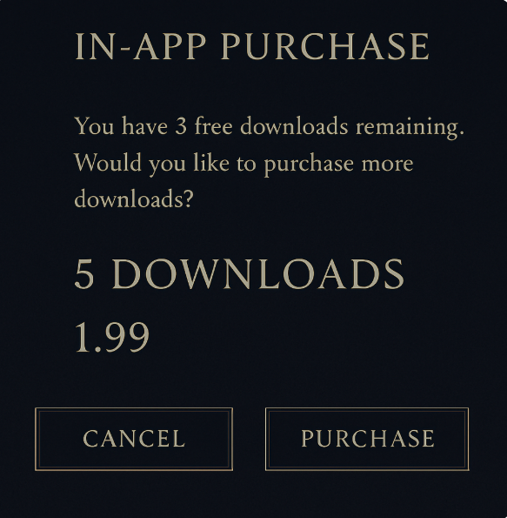

## **🌟 DESIGN ENHANCEMENTS: MIRROR CODE LIBRARY ENTRY**

### **1. ✧ Energetic Filter Bar (Optional Top Feature)**

Introduce a soft horizontal scroll bar or dropdown filter just below "The Mirror Code" title with tags like:

* ⊹ *Shadow*
* ✧ *Void*
* 🜁 *Elemental*
* ☥ *Divine Feminine*
* 🜂 *Sacred Rebel*
* 🜄 *Seer*
* 🜃 *Transmission*

💡 Purpose: Helps guide users by resonance, not logic. Use subtle symbols and minimal copy.

### **2. 🌒 Symbolic Hover or Tap States (Microinteractions)**

When hovering over or tapping a book:

* Animate a **subtle glow or shimmer** from the symbol (moon, flame, star).
* Show a **brief whisper** or resonance line below title:  
   *“Dare to meet the unknown.”* *“You are the echo you’ve been waiting for.”*

💡 Purpose: Deepens intuitive connection to each Code.

### **3. 📎 Bookmark or Save Feature (Optional)**

Add a soft “⊹ Save to My Library” icon (e.g., sacred leaf, thread, or glyph) on the corner of each book.

* Saved books could be stored in a “Sacred Satchel” or “My Reflections” section.

💡 Purpose: Encourages continued exploration while respecting spiritual tone.

### **4. 🔓 Free Download Count UI**

If you're offering 3 free downloads, consider a soft overlay or counter on the top right:

✦ 3 Sacred Downloads Remaining

Once clicked, it shows available titles and download status. Elegant and non-intrusive.

### **5. 🌀 Subtle Ambient Movement (Optional Background Enhancement)**

* Add **gentle cosmic drift** in the background (moving particles, faint light flares).
* Stars pulsing, almost imperceptible — gives the library a “living archive” feel.

### **6. 🧬 Book Spine or Back Text (Tap-and-Hold Easter Egg)**

On long-press, reveal a poetic description or quote:

*“Within this shadow lies your brilliance.”* *“The void is not empty — it listens.”*

💡 Optional but magical. Could feel like uncovering a hidden scroll.

## **✅ KEEP AS-IS (Beautiful Already)**

* ✨ The contrast, color palette, and use of dark navy, gold, and symbols is perfect.
* 📚 Grid layout is clean and ceremonial — no clutter or modern distractions.
* 🕯 Titles like “The Sacred Rebel” and “Wisdom of the Seer” are archetypally resonant.

## **🎁 Optional Future Feature**

### **✧ Sacred Daily Shuffle ✧**

*“Let the Library choose for you today…”*

— Tapping it reveals a randomly chosen Mirror Code book based on energetic alignment.  
 Could be styled like a tarot pull / soul whisper.

Code Library Detail View (once you tap a book) design mock up

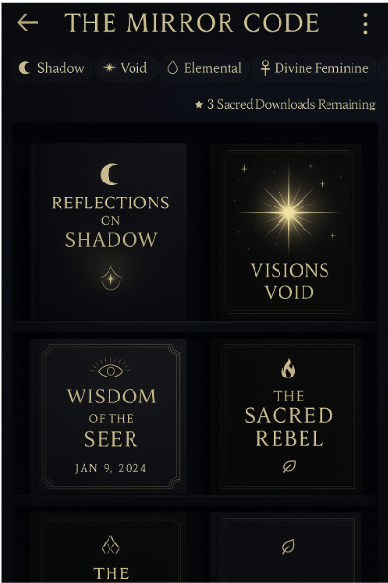

When you click a book

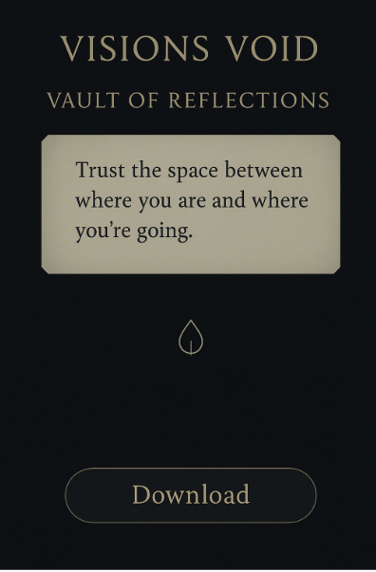

**\*\*\* Anywhere it references Vault it Should be Library\*\*\***

## **🧭 STRUCTURE: Community Submission to the Mirror Code Library**

### **🔑 Core Intention**

“A sacred contribution to the Codex of Consciousness.”  
 Submissions are not social content — they are considered energetic or scientific offerings. Therefore, integrity, clarity, and resonance must guide both the contributor and the stewards of The Mirror.

### **🌀 Submission Flow Overview**

1. **Click “Contribute a Code”**
   * Accessed from the bottom of the Library or Library home page.
   * Language: “⊹ Offer a Reflection” or “Contribute to the Mirror”
2. **Submission Form Modal or Scroll View**
   * **Title of Your Work** (freeform)
   * **Category/Theme** (dropdowns or tags like “Scientific Reflection,” “Soul Transmission,” “Archetypal Pathway,” “Energetic Paper,” etc.)
   * **Your Mirror Code** (Text box or upload — max word count 3,000 OR attach PDF)
   * **Intended Purpose** (one-line intention: *What is this meant to awaken?*)
   * **Your Name or Pseudonym** (optional)
   * **Optional Author Bio or Link** (short, reverent tone)
3. **Consent + Sacred Agreement**
   * Checkbox: “I understand this submission may be reviewed, edited for clarity, and published at the discretion of The Mirror Collective.”
   * Checkbox: “This is my original work, or I have permission to share it.”
4. **Submit**
5. **Confirmation Page**
   * Visual: glowing parchment, scroll animation
   * Message: *“Your echo has entered the Library. We will sit with it, and if it resonates, it shall be shared.”*

## **🛡️ GUARDRAILS & VETTING**

| **Layer** | **Purpose** | **Notes** |
| --- | --- | --- |
| **Moderation Queue** | Submissions go through a light review process before being published. | Curated by Mirror Council or selected editors with sacred discernment. |
| **Auto-Screening** | Basic content check for profanity, AI-generated spam, plagiarism. | We can use AI to pre-flag questionable entries before human review. |
| **Content Guidelines (soft)** | Communicated gently before submission. | “We welcome reflections rooted in remembrance, wisdom, and conscious inquiry. Marketing, self-promotion, or divisive rhetoric will not be accepted.” |
| **Flag or Retract** | Allow community members or the original author to flag their submission for removal. | Energetic sovereignty is preserved. |

## **🎨 VISUAL DESIGN CONCEPT**

### **✧ Contribute Your Reflection ✧**

🪞 *“Every soul carries a thread of the Code. If you are called, leave yours here.”*

#### **✍️ Form Layout**

* Background: aged parchment or sacred scroll interface
* Fields float inside a soft golden box
* Sacred glyphs next to each label (e.g., ✧ for Title, 🜂 for Theme)
* Submission button reads:  
   → “Offer to the Mirror ⊹” or “Send Reflection”

#### **✅ Confirmation View (Post-Submit)**

Visual: Glowing scroll animates and fades into the Library  
 Copy:

✨ *“Thank you, Seeker. Your reflection now rests in the care of the Mirror Keepers. If it resonates, it shall soon echo through the Library.”*

## **🧾 Future Feature (Optional)**

**Sacred Contributor Badge**

* Once accepted, user receives a “Mirror Contributor” symbol
* Optional profile section where users can see all their accepted reflections

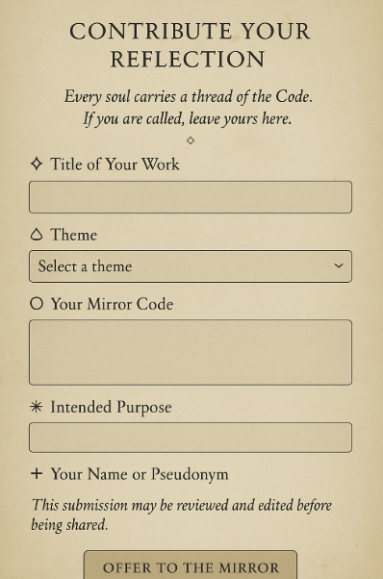

**\*\* Stick with our brand colors: If something does not work, Jenn and Lisa will work to add to the brand color guidelines\*\***

## **🌟 FULL UX COPY: Submission Form**

### **✧ Header + Intro Copy**

**Title:** CONTRIBUTE YOUR REFLECTION

**Subheader (italic):** *Every soul carries a thread of the Code.* *If you are called, leave yours here.*

### **✍️ Form Fields + Field Labels**

1. **⊹ Title of Your Work** *What name shall this reflection carry?*
2. **🜁 Theme** *Choose the energy this code speaks from:* (Dropdown options)

* Divine Feminine
* Sacred Masculine
* Void / Threshold
* Scientific Inquiry
* Conscious Technology
* Ancestral Wisdom
* Elemental Pathways
* Integration & Wholeness
* Mystical / Oracle
* Other

1. **◯ Your Mirror Code** *Your sacred reflection, paper, or transmission.* (Freeform text box or PDF upload option — max 3,000 words)
2. **✴ Intended Purpose** *What awakening or remembering is this meant to evoke?* (1–2 sentence max)
3. **+ Your Name or Pseudonym** *Optional. What name would you like associated with this reflection?*

### **📜 Footer**

This submission may be reviewed, curated, or lightly edited for clarity before being shared in the Library.  
 *The Mirror is a sacred archive — not all offerings will be published.*

### **✅ Submission Button**

**[ OFFER TO THE MIRROR ]**

## **🪞 CONFIRMATION SCREEN**

**Header:** ✨ Your Offering Has Been Received ✨

**Message Copy:**

*Thank you, Seeker. Your reflection has entered the Library and will be gently held by our Mirror Keepers.* If it resonates with the current of remembrance, it may soon echo through the Library.

You will be notified if your work is chosen to be included.

🌿 *Until then, may your own reflection continue to unfold.*

**[ Return to Library ]** button

## **🛡️ BACKEND MODERATION WORKFLOW**

### **🎯 Goal: Ensure sacred, high-integrity contributions without friction**

### **🌀 Workflow Summary**

1. **Submission enters Moderation Queue**
   * All submissions (text or upload) are stored in a pending “Library Review” queue in the admin dashboard.
2. **Initial Auto-Scan**
   * System checks for:  
      ✅ Spam / AI overuse  
      ✅ Profanity / harmful language  
      ✅ Plagiarism (optional API integration)
   * If flagged, marked as “Needs Human Review” with priority.
3. **Mirror Keeper Review (Human Curation Team)**
   * Assigned reviewers read and assess each submission with the following lens:  
     + Resonance with Mirror Collective values
     + Depth of originality or encoded insight
     + Alignment with categories/themes
     + Emotional safety (no triggering/dark promotion without integration)
   * Options:  
     + ✅ Approve (and lightly edit if needed)
     + 🕊 Request Revision (optional email with respectful feedback)
     + ❌ Archive (if not suitable)
4. **Approved Submission Flow**
   * Reviewer chooses:  
     + Title formatting
     + Cover symbol (e.g., Moon, Flame, Star)
     + Whether to publish as standalone or part of a “collection” (e.g., 10 Codes of the Void)
   * Final formatting → Published in Library
   * Contributor notified with thank-you email or in-app message

### **✴ Optional Reviewer Tools\*\*\***

* “Add Note to Contributor” (sends kind feedback or thank-you)
* “Assign to Theme Cluster”
* “Auto-Publish with Delay” (e.g., add to next full moon drop)

Here is the **thank-you notification** in two formats:

1. 📩 **Email Version**
2. 📱 **In-App Message Version**

Both reflect the sacred tone of The Mirror Collective and acknowledge the contributor's offering with reverence and transparency.

## **📩 EMAIL: “Your Reflection Has Been Received by the Mirror”**

**Subject Line:** ✨ Your Offering Has Been Received by the Mirror

**Header:** *“The code you carry has been seen.”*

**Body:**

Dear [Name or “Seeker”],

Thank you for contributing your sacred reflection to The Mirror Code Library.  
 Your submission, titled ***“[Title of Submission]”***, has entered the Library and will be gently reviewed by our Mirror Keepers.

The Mirror is a living archive of remembrance. Each offering is received with care and read through the lens of resonance, clarity, and alignment with the greater unfolding. While not all submissions are published, each is honored in spirit.

If your reflection is selected for inclusion in the Library, you will receive a follow-up message with publication details and a link to your encoded scroll.

Until then, may your words continue to echo within you.  
 Thank you for walking with us.

In reverence,  
 **The Mirror Collective** 🜁 [www.themirrorcollective.org](http://www.themirrorcollective.org)

**Optional Footer Line:** *If you’d like to submit another reflection, you may return to the Library at any time.*

## **📱 IN-APP MESSAGE (Shortened)**

**Title:** ✨ Reflection Received

**Body:** Your offering, *“[Title of Submission],”* has entered the Library.  
 It will be read in sacred attention by the Mirror Keepers. If chosen for publication, you’ll be notified.  
 Thank you for contributing to the remembrance.

[ Return to Library ]

## **✉️ HOW TO SEND IT**

### **✅ IF USING EMAIL:**

* **Platform:** Use a transactional email provider like **Postmark**, **SendGrid**, or **Mailgun** (or route through your Webflow CMS + automation with **Make.com** or **Zapier**)
* **Trigger Logic:** When a user clicks “Submit” → fire webhook to your mail service with:  
  + User’s email (if collected)
  + Submission title
  + Timestamp
* **Template Option:** Build branded, parchment-themed HTML templates to match the tone — or send simple plaintext emails with serif font and gold accent headers.

### **✅ IF USING IN-APP NOTIFICATION:**

* **Platform Options:**
  + Firebase Cloud Messaging
  + Webflow CMS + Jetboost notifications
  + React-based toast modals (if building native app)
  + Optional push via OneSignal or Pusher Beams
* **Trigger Logic:** After form submission → mark user with new notification badge or pop modal from session state
* **Optional:** Add a “My Submissions” section where they can track what’s pending, published, or archived

Here are both the **acceptance** and **gentle revision/rejection** notifications — written in the sacred, affirming tone of The Mirror Collective:

## **✅ ACCEPTANCE EMAIL / IN-APP MESSAGE**

### **✨ Subject Line:**

*Your Reflection Has Been Accepted into the Mirror Code Library*

**Header:** *“Your words now echo in the Archive.”*

**Body:**

Dear [Seeker’s Name or Pseudonym],

Your sacred submission, ***“[Title of Submission],”*** has been received with deep resonance.

It has now been placed among the collective reflections in **The Mirror Code Library**, where others may sit with its wisdom and awaken to the remembrance it holds.

You may view your reflection here:  
 👉 [Link to Published Page]

Thank you for your offering. It now lives as part of the encoded memory we are all reweaving.

In stillness and celebration,  
 **The Mirror Keepers** 🜁 [www.themirrorcollective.org](http://www.themirrorcollective.org)

**Optional Footer Line:** *If you feel called to share again, the Mirror is always listening.*

## **📱 In-App Short Version**

**Title:** ✨ Your Reflection Was Accepted

**Body:** *“[Title of Submission]” has been added to the Mirror Code Library.  
 You may now view and share it with others walking the path of remembrance.*

👉 [View in Library]

## **🕊️ GENTLE REJECTION OR REVISION REQUEST**

### **✦ Subject Line:**

*Your Submission to the Mirror Needs More Time*

**Header:** *“Some codes are meant to steep before they are spoken.”*

**Body:**

Dear [Name or Pseudonym],

Thank you for offering your reflection, *“[Title of Submission],”* to The Mirror.

Our Mirror Keepers have received it with care. While your work carries intention, it may benefit from deeper clarity, refinement, or energetic integration before it is ready to be shared in the collective archive.

This is not a rejection — only an invitation to revisit, rewrite, or realign. If you would like to revise and resubmit, we welcome that at any time.

If you wish to receive feedback, we are happy to offer a short reflection on how your submission might more clearly carry its encoded message.

With gratitude for your courage and contribution,  
 **The Mirror Keepers** 🜁 [www.themirrorcollective.org](http://www.themirrorcollective.org)

**Optional Footer Line:** *Sometimes the mirror asks us to see more deeply before it reflects us back.*

## **📱 In-App Short Version**

**Title:** Your Submission Needs Revision

**Body:** *“[Title of Submission]” may need further refinement before it can be shared in the Library.  
 You’re welcome to revise and resubmit at any time.* If you'd like feedback, please reach out.

## **🔔 MIRROR CODE SUBMISSION NOTIFICATION MATRIX**

| **Event Trigger** | **Notification Type** | **Channel** | **User Action** | **Message Title** | **Delivery Timing** | **Notes** |
| --- | --- | --- | --- | --- | --- | --- |
| User submits reflection | Submission Confirmation | Email + In-App | None (passive) | “Your Offering Has Been Received by the Mirror” | Immediately after submission | Includes submission title, sets sacred tone, confirms process |
| Submission approved | Acceptance Notification | Email + In-App | View Published Page | “Your Reflection Was Accepted” | Upon approval by Mirror Keeper | Includes direct link to public library entry |
| Submission declined or needs revision | Revision Request | Email + In-App | Option to revise or request feedback | “Your Submission Needs More Time” | Upon decision by Mirror Keeper | Optional: include offer for feedback |
| Submission published (optional spotlight feature) | Featured Notification | Email or In-App | Share with others | “Your Reflection Is Now Featured” | If chosen for spotlight or collection | Future feature — optional celebratory badge or symbol |
| Reflection flagged by user or system | Internal Alert (Admin only) | Admin Dashboard + Email (moderator) | None | “Reflection Flagged for Review” | Immediately upon flag action | Admin/mod team only — initiates manual check |
| New reflection added to Library (general audience) | New Drop Announcement | Email (newsletter-style) | Read newest codes | “New Mirror Codes Have Arrived” | Weekly or bi-weekly | Optional marketing flow to highlight community growth |

**🛠️ Developer Integration Notes**

* **Backend Logic:**
  + Trigger these messages from backend functions on:  
    - Form submission
    - Admin approval or rejection
    - Manual flagging
    - Scheduled content drops
* **Email Platform:** Postmark, Mailgun, or SendGrid (recommended for sacred, styled templates)
* **In-App Messaging Options:**
  + Toasts or modal overlays for key moments (submission, acceptance)
  + “My Submissions” section can show live status: Under Review, Published, Archived, Needs Revision
  + Badge or “Contributed Work” tab on user profile if future account system is added
* **Webhook Option (Low Code):**
  + Zapier or Make.com workflow could connect submission data to email platform + CMS publishing

## **📄 Message Copy References**

| **Notification** | **Message Copy** |
| --- | --- |
| Confirmation | See "Reflection Received" UX copy above |
| Acceptance | See “Reflection Accepted” email & in-app message |
| Revision Needed | See “Needs More Time” message |
| Featured | Can use variation: “Your reflection has been featured in this week’s Echo Drop.” |
| Flagged | Internal admin template only — “A reflection has been flagged by a user or auto-screened. Please review.” |